Name_______________________________
Polymerization- Slime Time and smells
There are a variety of different types of polymers out there. The polymer made in class is going to a crosslinked polymer made from polyvinyl alcohol solution and borax. This polymer has some interesting properties.
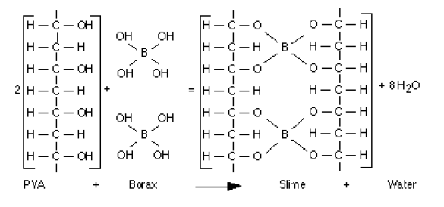
Procedure
Polymer 1
- In a 100 mL beaker add 20 mL of Polyvinyl alcohol solution.
- You may add food coloring to this solution if you want, although this is not necessary (one or two drops).
- Add 5 mL of borax solution.
- Stir the mixture with a scoopula.
- Once the solution clumps too much to stir with the scoopula take it out of the beaker and knead it in your hand for 5-10 minutes.
- Your polymer will change to being more firm.

Polymer 2

- In a 100 mL beaker mix 5 mL of Borax solution, 5 mL of Elmer’s glue, and 5 mL of cornstarch.
- You may add food coloring if you want, although it is not necessary.
- Stir the mixture with a scoopula.
- Once the solution clumps too much to stir with the scoopula take it out of the beaker and knead it in your hand for 5-10 minutes.
- Your polymer will change to being more firm.
Polymer 3

- In a 100 mL beaker mix 5 mL of Borax solution, 5 mL of Elmer’s glue, and 5 mL of cornstarch and 30 mL of Shaving cream
- You may add food coloring if you want, although it is not necessary.
- Stir the mixture with a scoopula.
- Once the solution clumps too much to stir with the scoopula take it out of the beaker and knead it in your hand for 5-10 minutes.

Polymer 4 Polyester

  - There are 2 carboxylic acids in dropper bottles; acetic acid and propanoic acid. BOTH ARE HIGHLY CONCENTRATED AND DANGEROUS!! There are also 5 different alcohol solutions; isopentyl alcohol, 1 butanol, 1 propanol, ethanol and methanol.
  - Choose one alcohol and one carboxylic acid. In a centrifuge tube add 10 drops of alcohol and 20 drops of carboxylic acid.
  - Add one drop of sulfuric acid. THIS IS 18 M, USE EXTREME CAUTION!!
  - Seal the centrifuge tube and place it in a deep well plate.
  - Repeat this with 3 other combinations for a total of 4 centrifuge tubes.
  - Fill the deep well plate with the tube with hot water and let it sit for 10 minutes.
  - After 10 minutes, open the tube and waft the fumes to smell them.
  - Put the liquid in the waste container marked for this lab, and rinse the tubes out.

Combination
Alcohol Carboxylic acid Description of scent
1.

2.

3.

4.

- Describe the properties of your slime polymers. Compare and contrast them. What happens when you make it into a shape and leave it on the table, does it bounce, how does it feel when you throw it up and catch it etc.?

- Fully describe what a polymer is and how it forms.

